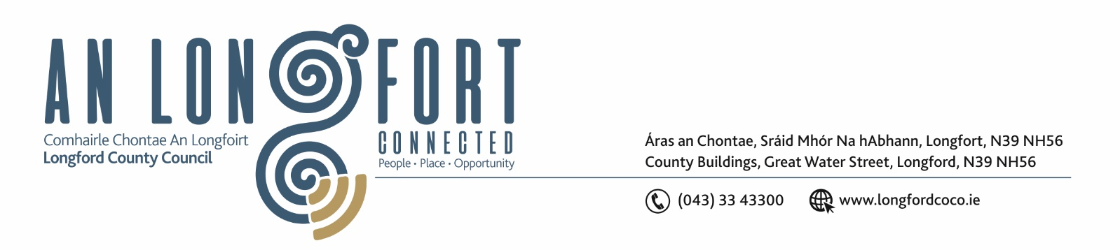

5u Mean Fomhair 2018.

Chuig: Gach Ball don Chomhairle.

A Chomhairleoir,

Iarrtar ort bheith i láthair ag Cruinniú Míosuil Chomhairle Chontae Longfoirt a tionólfar i Seomra na Comhairle, Aras an Chontae, Longfoirt ar an Chéadaoin, 12u Mean Fomhair 2018 ag 4.00 p.m chun gnó a dhéanamh d’réir an Chláir thíos.

You are requested to attend the Monthly Meeting of Longford County Council to be held in the Council Chamber, Aras an Chontae, Great Water Street, Longford, on Wednesday, 12th September 2018 at
4.00 p.m. to transact business, as set out on the Agenda hereunder.

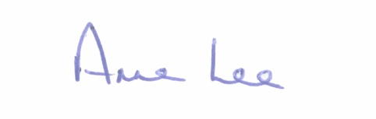
Mise le meas,

_______________
Anne Lee,
Meetings Administrator.

C L A R

Prayer before Meeting.

- Confirmation of Minutes of Monthly Meeting of Longford County Council held on the
11th July 2018 - copy enclosed.

2. Matters arising from Minutes.

3. To note Chief Executive Orders. (Summary herewith)

4. To note Monthly Management Report - to follow.

5. To note adopted Minutes of Corporate Policy Group Meeting held on
13th June 2018 - (copy enclosed).

6. Economic and Community Development, Planning, Human Resources & Corporate Services, Cultural & Recreational Services.

- To note Planning Applications received since July meeting of the Council.

- Consideration of Adoption of Part 8 Report (Planning and Development Act 2000 (as amended) and Planning and Development Regulations 2001) (as amended) in respect of proposal to carry out a development referred to as – 1 no. 2 bed single storey dwelling at Darogue, Ballymahon, Co. Longford - details attached.

(c) Consideration of Adoption of Part 8 Report (Planning and Development Act 2000 (as amended) and Planning and Development Regulations 2001) (as amended) in respect of proposal to carry out a development referred to as – 2 no. 3 bed semi-detached houses at Knock, Lanesborough, Co. Longford - details attached.

(d) Consideration and adoption of Draft Intercultural Strategic Plan for County Longford -
(Draft enclosed )

(e) Notices of Motions submitted by Councillors, as listed hereunder –

Councillor Peggy Nolan

“That Longford County Council should utilise the wealth of local photographic talent to capture the beauty of Longford towns and landscape. Images thus gathered should be compiled in a professionally produced book which could be sold in local shops, the Tourist Office and directly online to Longford DIASPORA”.

Councillor Mae Sexton

“That Longford County Council takes in charge Mastertech Business Park on the Royal Canal Avenue on Athlone Road”.

7. Finance & Information Systems.

(a) To note Public Liability Claims received during July and August 2018 – report enclosed.

(b) To consider the Local Property Tax Variation in accordance with the provisions of Section 20 of the Finance (Local Property Tax) Act 2012.

8. Housing, Infrastructure, Environment & Emergency Services.

(a) Consideration of disposal of Freehold Interest of Property at No. 18, Connolly Crescent, Longford to John Ryan in accordance with the terms of Section 183 of the Local Government Act 2001 issued on the 7th August 2018.

- Consideration of leasing of lands at Currycahill, Ballinalee Co. Longford to St. Emer’s Cemetery Committee, Ballinalee, Co. Longford in accordance with the terms of Section 183 of the Local Government Act 2001 issued on the 24th August 2018.

- Consideration of disposal of lands at Kilcommock, Kenagh, Co. Longford to Legal Personal Reps Mulvihill family, Kilcommock, Kenagh, Co. Longford by way of Deed of Exchange in accordance with the terms of Section 183 of the Local Government Act 2001 issued on the 27th August 2018.

- To note Differential Rents Scheme 2018 - report enclosed.

(e) Notices of Motions submitted by Councillors, as listed hereunder –

Councillor Peggy Nolan

“That Longford County Council install industry standard metal brackets on the map posts in the centre of Longford. The purpose of these brackets will be to support the display of professionally produced individually distinct banners”.

Councillor Paul Ross

“That Longford County Council write to the Minister for Housing to ask for an increase in HAP payment to eligible families in County Longford as current payments do not reflect rental market values in Longford.”

9. General

- Notices of Motions submitted by Councillors, as listed hereunder –

Councillor Mark Casey.

“That this Council does not charge for parking while people are charging their electric vehicles. Longford is one of only three local authorities that impose parking fees whilst charging, the others being Dublin and Limerick City Councils.
We should encourage the use of electric vehicles and this action would be a positive step in that direction .”

“That Longford County Council do hereby nominate Seán Gallagher of Eden Gate, Delgany, Greystones, Co. Wicklow as a candidate for the Election for the Office of President of Ireland pursuant to Article 12 of Bunreacht na hÉireann and the Presidential Election Act 1993 as amended.

- Correspondence – copies enclosed.

- Nominations for President of Ireland.
- Correspondence received from John Groarke, Castlerea, Co. Roscommon, seeking support for his nomination as a candidate for President of Ireland.
- Correspondence received from Peter Casey, Links Business Centre, Lisfannon, Co. Donegal seeking support for his nomination as a candidate for President of Ireland.

(ii) Letter dated 12th July 2018 received from the Office of the Minister for Health concerning child psychology waiting lists.

(iii) Letter dated 23rd July 2018 received from the Office of the Minister for Health concerning the establishment of an Ombudsman for People with Disabilities.

(iv) Letter dated 26th July 2018 received from the Office of the Minister for Health concerning the Fair Deal Scheme and Farm Assets.

(v) Letter dated 24th August 2018 received from the Office of the Minister for Housing concerning recent Notice of Motion in connection with commercial rates.

10. Votes of sympathy.

11. Training -
Consideration of Report from Corporate Policy Group.



